Date | 03 October 2026
Team ID | SWTID-2026-7735
Project Name | Auto Ticket Classification using Flow Designer
Maximum Marks | 4 Marks

Requirement Analysis
Customer Journey Map
Customer Journey Map: School IT Support Experience
A Customer Journey Map visualizes the complete student and educator journey from initial classroom technology failure to automated classification and resolution.
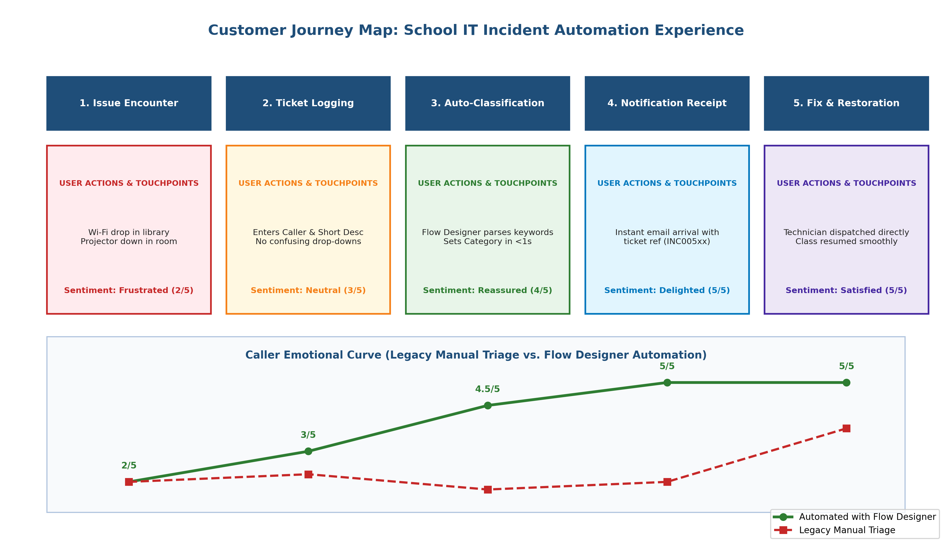
Figure 2.1: School IT Incident Automation Customer Journey Map & Emotional Touchpoints
Journey Dimension | Stage 1: Issue Encounter | Stage 2: Ticket Submission | Stage 3: Automated Classification | Stage 4: Caller Notification | Stage 5: Resolution & Feedback
User Action | Teacher encounters projector failure or Wi-Fi disconnection. | Enters Caller and Short Description in ServiceNow form. | Flow Designer evaluates keywords and updates Category/Subcategory. | Caller receives instant confirmation email with ticket number. | Technician resolves problem; caller confirms restoration.
Touchpoints | Classroom equipment, Laptop Wi-Fi settings. | ServiceNow Incident Workflow Form (u_incident_workflow). | ServiceNow Flow Designer Backend Engine. | ServiceNow Email Engine (sys_email), Caller Inbox. | ServiceNow Platform record update.
User Thoughts | 'Class starts in 5 minutes, I need help immediately!' | 'I'll just type what is broken, hope I don't need IT jargon.' | 'System classifies my issue in real time without human delay.' | 'Great! Confirmation email arrived in my inbox.' | 'Classroom tech restored, minimal instructional disruption.'
Emotional Curve | Frustrated / Stressed (2/5) | Neutral / Hopeful (3/5) | Reassured (4.5/5) | Delighted (5/5) | Satisfied (5/5)
Opportunities | Provide quick links and QR codes on classroom podiums. | Require only Caller & Short Description; auto-classify Category. | Flow Designer matches keywords (WiFi, Projector, Password, Slow). | Automated email action with dynamic data pills. | Auto-route to specialized teams (Network, Hardware).

